DATE:

EX.No.:7 REPRESENTATION OF MAP

AIM:

To perform Data Analysis and representation on a Map using various Map data sets with Mouse Rollover effect, user interaction, etc .

DATASET:

The  dataset to map some countries in the analysis: Advanced Global Warming Analysis with Plotly.

**PROGRAM:**

import pandas as pd  
iso_df = pd.read_csv(filepath_or_buffer='/content/continents2.csv',  
 usecols=['name', 'alpha-3', 'region'],).rename(columns={'name': 'Countries'})  
iso_df.head()

Countries alpha-3 region  
0 Afghanistan AFG Asia  
1 Åland Islands ALA Europe  
2 Albania ALB Europe  
3 Algeria DZA Africa  
4 American Samoa ASM Oceania

country_fixes = \  
{'Ant.& Barb.' : 'Antigua and Barbuda',  
 'Bosnia & Herz.' : 'Bosnia And Herzegovina',  
 'Brunei' : 'Brunei Darussalam',  
 'Burma' : 'Myanmar',  
 'C.A. Republic' : 'Central African Republic',  
 'Cape Verde' : 'Cabo Verde',  
 'Czechia' : 'Czech Republic',  
 'DR Congo' : 'Congo (Democratic Republic Of The)',  
 'Domin. Rep.' : 'Dominican Republic',  
 'Eq. Guinea' : 'Equatorial Guinea',  
 'G.-Bissau' : 'Guinea Bissau',  
 'Ivory Coast' : "Côte D'Ivoire",  
 'Micronesia' : 'Micronesia (Federated States of)',  
 'North Macedonia' : 'Macedonia',  
 'Papua N.G.': 'Papua New Guinea',  
 'R. of Congo' : 'Congo',  
 'S.T.&Principe' : 'Sao Tome and Principe',  
 'Solomon Isl.' : 'Solomon Islands',  
 'St. Vincent & ...' : 'Saint Vincent and the Grenadines',  
 'Swaziland' : 'Eswatini',  
 'Tr.&Tobago' : 'Trinidad and Tobago',  
 'UA Emirates' : 'United Arab Emirates',  
 'UK' : 'United Kingdom',  
 'USA' : 'United States'}  
drop_columns = ['Global rank', 'Available data']  
print('loaded country fixes and drop columns')

loaded country fixes and drop columns

inflation_df = pd.read_csv(filepath_or_buffer='/content/Inflation forecast.csv').drop(columns=drop_columns)  
inflation_df['Countries'] = inflation_df['Countries'].replace(to_replace=country_fixes)  
inflation_df.head()

Countries Inflation forecast, 2023  
0 Venezuela 249.98  
1 Zimbabwe 181.75  
2 Argentina 88.04  
3 Sudan 65.26  
4 Turkey 45.00

from numpy import log10  
df = inflation_df.merge(right=iso_df, on='Countries', how='inner')  
df['log10_forecast'] = df['Inflation forecast, 2023'].apply(log10)  
df.info()

<class 'pandas.core.frame.DataFrame'>  
Int64Index: 186 entries, 0 to 185  
Data columns (total 5 columns):  
 # Column Non-Null Count Dtype   
--- ------ -------------- -----   
 0 Countries 186 non-null object   
 1 Inflation forecast, 2023 186 non-null float64  
 2 alpha-3 186 non-null object   
 3 region 186 non-null object   
 4 log10_forecast 183 non-null float64  
dtypes: float64(2), object(3)  
memory usage: 8.7+ KB

from plotly.express import histogram  
histogram(data_frame=df, x='Inflation forecast, 2023', hover_name='Countries', color='region')

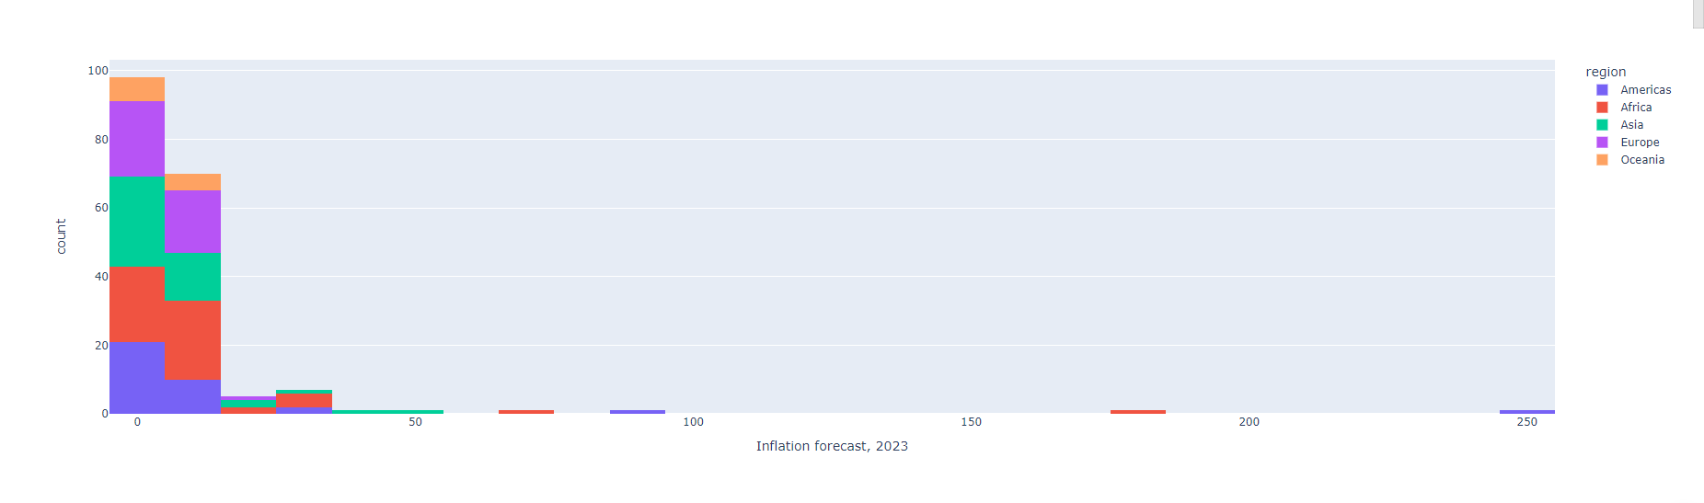

**OBSERVATION:**

This graph shows the inflation forecast for 2023 for different countries, grouped by region. The x-axis shows the inflation forecast, and the y-axis shows the number of countries. The graph is color-coded by region, with Africa in orange, Asia in purple, Europe in green, and Oceania in blue. The highest inflation forecast is for Africa, with around 100 countries having a forecast of around 50. The lowest inflation forecast is for Oceania, with only a few countries having a forecast of around 0.

from plotly.express import choropleth  
choropleth(data_frame=df, locations='alpha-3', color='Inflation forecast, 2023', hover_name='Countries')

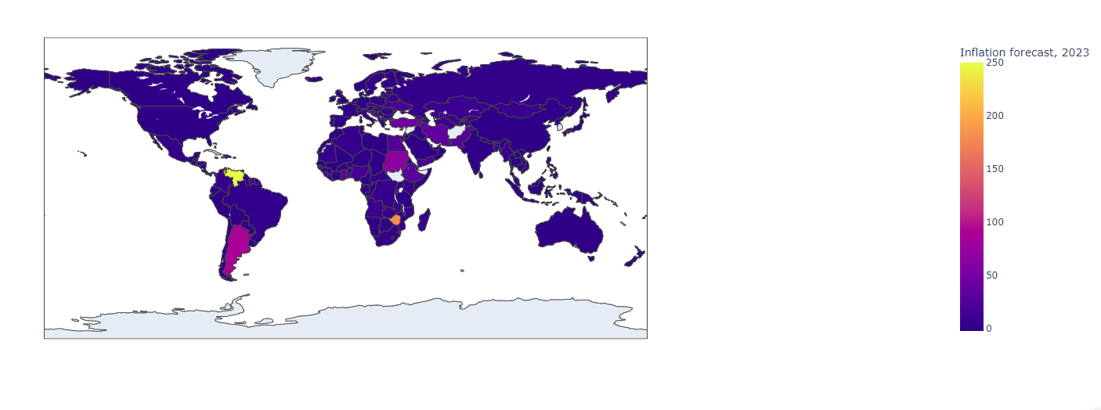

**OBSERVATION:**

This is a map of the world with countries represented by their alpha-3 code. The color of the country represents the inflation forecast for 2023, with purple being the highest and yellow being the lowest. Countries with the highest inflation forecast are located in Africa and South America, while countries with the lowest inflation forecast are located in Europe and North America. The legend on the right side of the map shows the range of the inflation forecast.

histogram(data_frame=df, x='log10_forecast', hover_name='Countries', color='region')

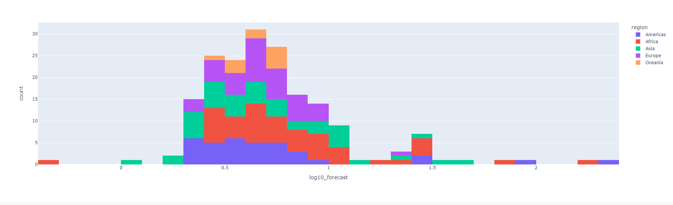

**OBSERVATION:**

This is a histogram graph with information x='log10_forecast', hover_name='Countries', color='region'. The x-axis is the logarithmic forecast values and the y-axis is the count of countries. The different colors represent different regions. The region with the highest count of countries is Asia. The highest count of countries is around 0.5 on the x-axis.

choropleth(data_frame=df, locations='alpha-3', color='log10_forecast', hover_name='Countries', hover_data='Inflation forecast, 2023', color_continuous_scale='Reds')

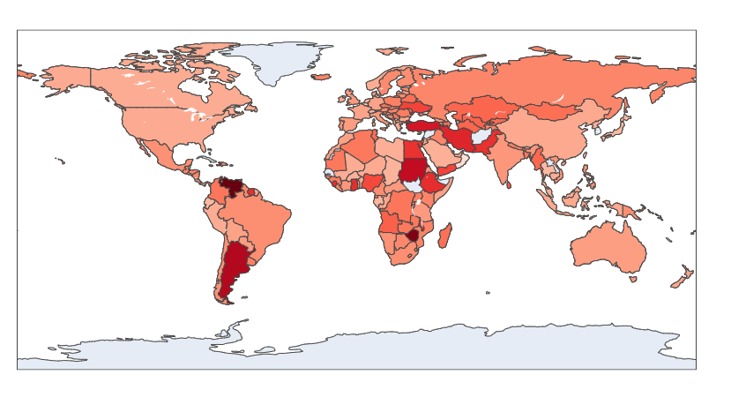

**OBSERVATION:**

This is a world map with countries shaded in different shades of red. The darker the shade, the higher the forecasted inflation for 2023. The countries with the highest forecasted inflation appear to be in Africa and the Middle East. The map is labeled with alpha-3 country codes. The color scale is logarithmic, with the darkest red representing the highest forecasted inflation. The map has hover data for each country, including the country name and the forecasted inflation for 2023.

budget_df = pd.read_csv(filepath_or_buffer='/content/Budget balance forecast.csv').drop(columns=drop_columns)  
current_df = pd.read_csv(filepath_or_buffer='/content/Current account forecast.csv').drop(columns=drop_columns)  
growth_df = pd.read_csv(filepath_or_buffer='/content/Economic growth forecast.csv').drop(columns=drop_columns)  
investment_df = pd.read_csv(filepath_or_buffer='/content/Investment forecast.csv').drop(columns=drop_columns)  
unemployment_df = pd.read_csv(filepath_or_buffer='/content/Unemployment rate forecast.csv').drop(columns=drop_columns)  
for item in [budget_df, current_df, growth_df, investment_df, unemployment_df]:  
 print(item.shape)

(78, 2)  
(185, 2)  
(185, 2)  
(166, 2)  
(101, 2)

all_df = budget_df.copy()  
for item in [current_df, growth_df, inflation_df, investment_df, unemployment_df]:  
 all_df = all_df.merge(right=item, on='Countries', how='left')  
all_df['Countries'] = all_df['Countries'].replace(to_replace=country_fixes)  
all_df = all_df.merge(on='Countries', how='inner', right=iso_df)  
all_df.head()

Countries Budget balance forecast, 2023 Current account forecast, 2023 \  
0 Grenada 2.66 -15.03   
1 Ireland 2.25 8.19   
2 Cyprus 1.31 -7.85   
3 Singapore 0.68 15.50   
4 Denmark 0.55 9.45   
  
 Economic growth forecast, 2023 Inflation forecast, 2023 \  
0 3.66 3.25   
1 5.58 3.01   
2 2.52 2.75   
3 1.50 5.45   
4 NaN 3.80   
  
 Investment forecast, 2023 Unemployment rate forecast, 2023 alpha-3 \  
0 25.50 NaN GRD   
1 27.42 4.48 IRL   
2 20.17 6.45 CYP   
3 25.12 2.10 SGP   
4 25.29 5.10 DNK   
  
 region   
0 Americas   
1 Europe   
2 Asia   
3 Asia   
4 Europe

from plotly.express import imshow  
imshow(img=all_df.corr(numeric_only=True))

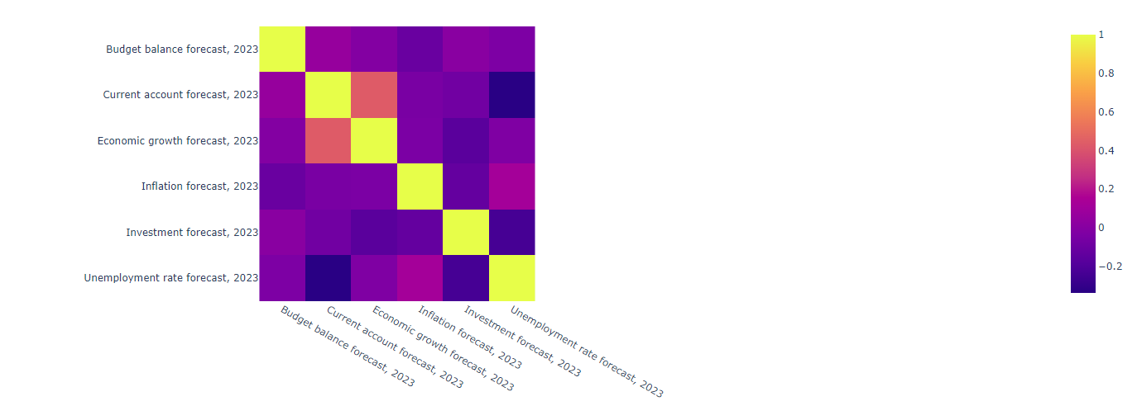

**OBSERVATION:**

This graph appears to be a correlation matrix of economic indicators for the year 2022. The diagonal line of the matrix is a perfect positive correlation, while the off-diagonal elements show varying degrees of positive and negative correlation. The x and y axis labels are “Budget balance forecast 2022”, “Current account forecast 2022”, “Economic growth forecast 2022”, “Inflation forecast 2022”, and “Unemployment forecast 2022”. The color scale ranges from purple (negative correlation) to yellow (positive correlation).

from plotly.express import scatter  
scatter(data_frame=all_df, x='Economic growth forecast, 2023', y='Current account forecast, 2023', color='region', hover_name='Countries',  
 trendline='ols', trendline_scope='overall')

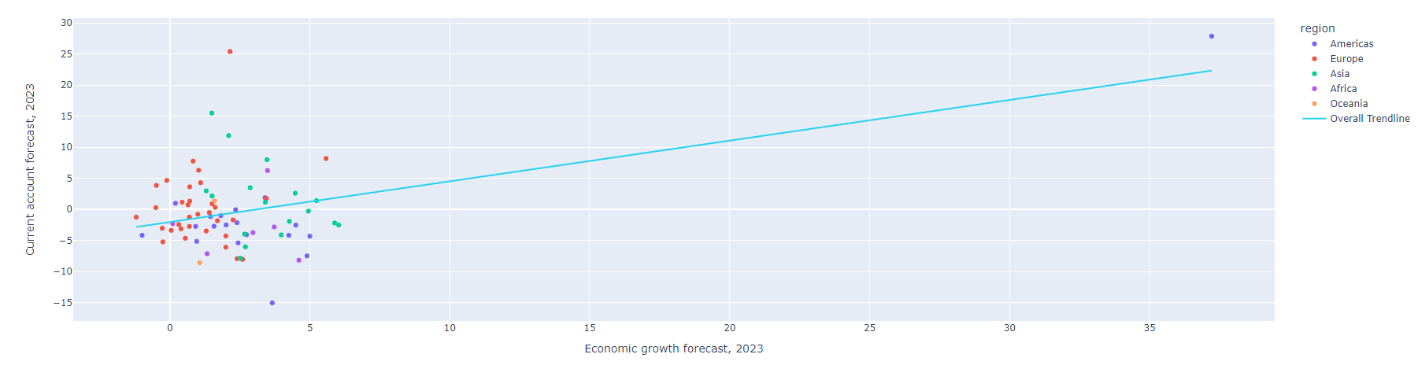

**OBSERVATION:**

This graph shows the relationship between economic growth forecast and current account forecast for different regions in 2023. The overall trendline shows a positive relationship between the two variables. The points are colored by region, with blue representing Europe, red representing Asia, green representing Africa, and purple representing the overall trendline. The points are labeled with the country names when hovered over.

columns = ['Budget balance forecast, 2023', 'Current account forecast, 2023', 'Economic growth forecast, 2023', 'Inflation forecast, 2023',  
 'Investment forecast, 2023', 'Unemployment rate forecast, 2023',]  
print(sorted(columns))

['Budget balance forecast, 2023', 'Current account forecast, 2023', 'Economic growth forecast, 2023', 'Inflation forecast, 2023', 'Investment forecast, 2023', 'Unemployment rate forecast, 2023']

from plotly.express import scatter_matrix  
scatter_matrix(data_frame=all_df[columns],)

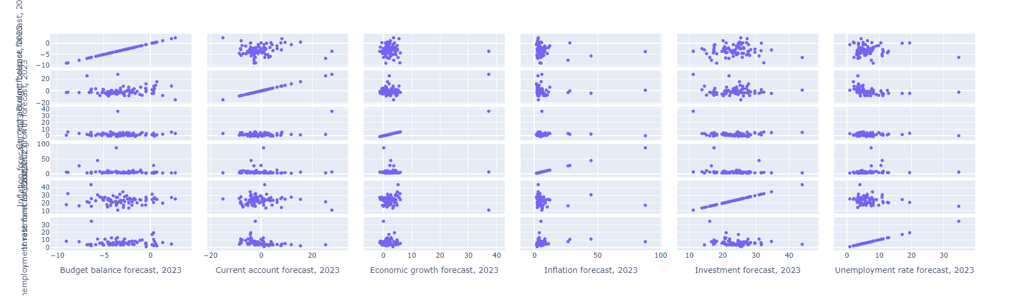

**OBSERVATION:**

This graph shows the forecast for various economic indicators for the year 2023. The average for 2023 based on 80 countries was -2.87 percent. The highest value was in Grenada: 2.77 percent and the lowest value was in India: -8.79 percent.Global growth is projected to fall from an estimated 3.5 percent in 2022 to 3.0 percent in both 2023 and 2024. Global growth is projected to be 2.9% in 2023, and weaken to 2.7% in 2024⁶.Global headline inflation is expected to fall from 8.7 percent in 2022 to 6.8 percent in 2023 and 5.2 percent in 2024.Nearly 48% of investors have a negative investment outlook.The baseline forecast is for growth to fall from 3.4 percent in 2022 to 2.8 percent in 2023, before settling at 3.0 percent in 2024.

from plotly.offline import init_notebook_mode  
from plotly.offline import iplot  
  
def make_plot_data() -> dict:  
 data = [dict(type='choropleth', locations = all_df['alpha-3'],  
 z=all_df[column],  
 hovertext=all_df[['Countries', column]]) for column in columns]  
 steps = [dict(method='restyle', args=['visible', [other == column for other in columns]], label=column) for column in columns]  
 layout = dict(geo=dict(scope='world'), sliders=[dict(active=0, pad={'t': 1}, steps=steps)], )  
 return dict(data=data, layout=layout)  
  
init_notebook_mode()  
iplot(figure_or_data=make_plot_data())  
plot.show()

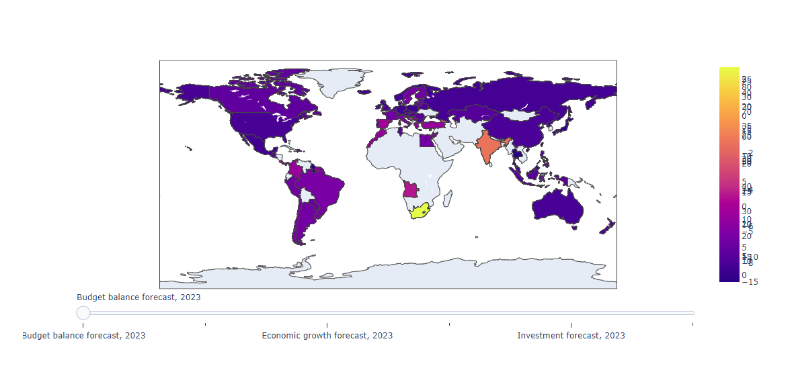

**OBSERVATION:**

The graph appears to be a forecast of budget balance, economic growth, and investment for the year 2023. The budget balance forecast for 2023 is expected to be -2.87 percent on average based on 80 countries, with the highest value being in Grenada: 2.77 percent and the lowest value being in India: -8.79 percent.

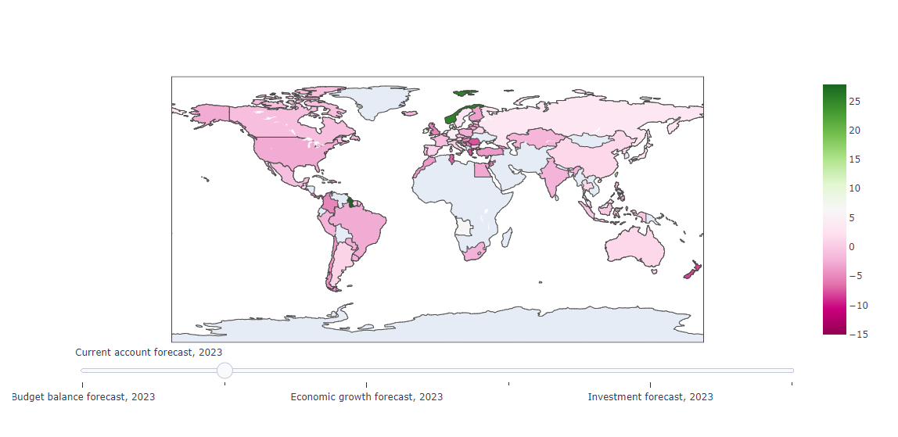

**OBSERVATION:**

The graph shows the current account forecast for 2023. The forecast is positive for most countries, with the exception of a few countries in Africa and the Middle East. The current account forecast measures the projected value of a country's net international transactions with the rest of the world. It includes all the transactions (other than those in financial items) that involve economic values and occur between resident and non-resident entities. Projections are based on an assessment of the economic climate in individual countries and the world economy, using a combination of model-based analyses and expert judgement.

**POWERBI:**

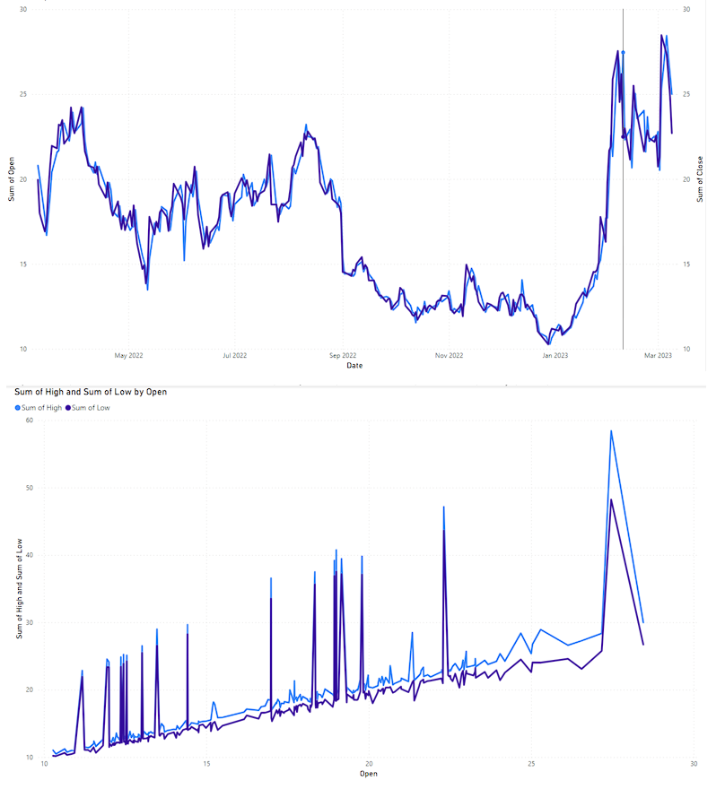

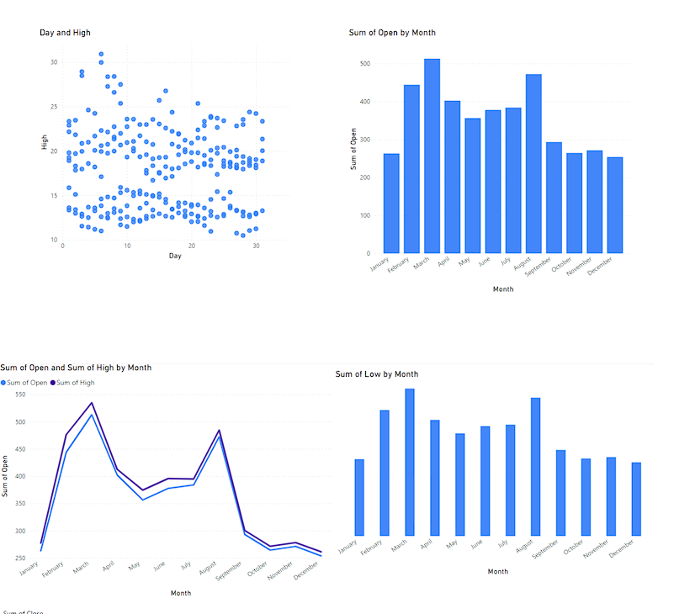

**RESULT:** The performing Data Analysis and representation on a Map using various Map data sets with Mouse Rollover effect, user interaction, etc has been done successfully.